
Gas-Power Interdependence
Knock-on Effects of the Dash to Gas

Introduction
The energy industry has recently been turned on its head as natural gas prices have held below $4 per MMBTU for several years. This is driven by significantly greater supply as natural gas producers begin to exploit and extract as much as 300 trillion cubic feet of estimated reserves, including those accessible through unconventional drilling, especially hydraulic-fracturing techniques.

The combination of evolving environmental regulations limiting reliance on coal generation and low gas prices has led to a significant increase in the amount of gas-fired generation in the United States. Low gas prices and significant financial hurdles are limiting the prospects for new nuclear. Renewables are not economical without subsidies, and when they are a significant part of the generation mix, they require quick response grid support that gas-fired generation can provide.

The current assumption in the energy industry is that these trends will continue and could lead to an unprecedented reliance on natural gas generation. A recent Energy Information Administration estimate found that gas could account for 25% of power generation by 2020, up from 20% in 2010. As such, it is worth considering the degree to which the electric and gas industries have become dependent upon one another and the implications of that interdependence.

ScottMadden believes there are five characteristics of interdependence that may threaten the reliability of the grid in certain circumstances.

- “Co-dependence”: Electric and gas industries are becoming more “co-dependent.” The reliability of the electric industry is increasingly dependent on gas-fired generation and its associated infrastructure. Much gas infrastructure is dependent on electricity to operate. Failure in either sector now has potential reliability impacts or cascading effects on the other. The risk of common mode failures is increasing.
- Increased volumetric requirements: The gas-fired plants being built today are different from earlier generations, because they require higher gas pressure and consume larger amounts of gas on a daily basis than previous ones, placing greater demands on the existing infrastructure.
- Reliance on interruptible contracting: The current balance of firm and interruptible contracts to meet the needs of gas-fired generation may not align with the needs of the grid in certain regions.
- Operational mismatches: As far back as the early 2000s, industry participants and standards makers, like North American Energy Standards Board, identified the lack of alignment between the trading days for gas and electricity as a potential systemic weakness and an important area of coordination. Further, the planning horizons for the two industries are significantly different, which may result in building the infrastructure most easily (or quickly) deployed while not considering the optimal reliability solution for the region.
- System design vs. emerging usage patterns: The gas pipeline system was designed to do one thing—move gas from supply centers to demand centers primarily for retail use—and now we are asking it to do something quite different in locations served, pressures required, and reserve capacity maintained. This introduces system constraints. In some cases, the gas pipeline infrastructure may be insufficient to handle coincident heating load and electric load
peaks, especially if any tipping point factors are present, such as the loss of significant coal generation. This was demonstrated by rolling blackouts in the Southwest in February 2011, as coal units failed during a cold snap, heating load peaked, and many generators needed a five-fold increase in gas supply and could not obtain it.

These issues are surfacing across the country, most acutely in regions with the highest dependence on gas-fired generation. Some regions, driven by the proverbial wolf at the door, have been very proactive in attempting to resolve these challenges. Others have been less proactive and less organized in their responses.

What are the Possible Impacts of Expanded Power Generation on Gas Infrastructure?
Gas-fired generation now makes up 22% of the generation mix in the United States, and it comprises more than 40% of that mix in New England and Texas. However, these are not the only regions that must consider the risks attendant with gas-power interdependence.

Table 1 shows that nine of the ten largest (by volume) generating companies in the United States reduced their use of coal in generation from 2010 to 2011. Of these nine, eight concurrently increased gas-fired generation.

Table 1: Fuel Mix of Top 10 U.S. Generators

Fuel Mix of  Top 10 U.S. Generators | Coal Share of Total Gen |  | Gas Share of Total Gen
Fuel Mix of  Top 10 U.S. Generators | 2010 | 2011 | 2010 | 2011
Southern Co. | 57% | 51% | 25% | 30%
NextEra Energy | 4% | 3% | 51% | 57%
American Electric Power | 81% | 77% | 8% | 11%
Exelon | 5% | 3% | 1% | 1%
TVA | 49% | 47% | 7% | 8%
Duke Energy | 60% | 57% | 7% | 10%
Entergy | 13% | 12% | 23% | 25%
First Energy | 64% | 70% | 0% | 0%
Dominion Resources | 38% | 32% | 14% | 19%
Progress Energy | 45% | 36% | 29% | 32%
(Source: FERC Data; ScottMadden analysis)

This increased power generation demand will place significant strain on natural gas pipelines. For example, the Midwest Independent Transmission System Operator (MISO) recently performed an analysis which concluded that replacing 12 GW of coal generation with gas-fired generation would lead to gas deliverability problems. These problems occur as the existing pipeline system simply does not have enough capacity to take on this additional power generation.
Consider the Northern Border Pipeline (NBP), which runs from Montana to Indiana. Current throughput capacity on the NBP is approximately 2 BCF per day and has annual capacity utilization of about 65%. In the worst case scenario, MISO found that the effect of an extra 12 GW leaning on the NBP due to coal plant retirements would mean the pipeline’s gas-fired combined-cycle generators could face insufficient pipeline capacity of up to almost half the days in the year. MISO found that up to 102 days in summer and up to 78 days in winter would be underserved by NBP.

Common Mode Failures and the Gas-Electric Negative Feedback Loop
As more gas-fired generation is added to the grid, the electric industry faces increased risk associated with common mode failure. Common mode failure occurs when multiple failures are caused by a single fault. To the extent that multiple gas-fired generators are dependent upon a single gas pipeline, if that pipeline fails or has insufficient capacity for a coincident heating and generation peak, several generating facilities may also go down.

Transmission planning criteria require planning for the single or two worst contingencies on the system (including the loss of generating units). However, they do not plan for these more extreme eventualities such as loss of pipeline capacity. Importantly, this loss of pipeline capacity could be due to physical failure of the facility (though rare) or due to lack of contracted capacity for gas.

When a generating unit is built, it is assumed (for transmission planning purposes) to be available to address system contingencies. The reality is that may not be the case if issues around gas supply are not addressed. For instance, loss of a single generator could cause multiple gas-fired units to be called up; sudden demand could cause pipeline pressures to drop and reduce quality of service to other customers including generators. This could potentially lead to another common mode failure.

Because grid stability depends on the network of generators available and running, a common mode failure in generation of sufficient scope and immediacy could also lead to grid instability, rolling blackouts, or collapse.

Electric transmission service interruptions can affect service to motor-driven gas compressor stations. On peak days, just as electricity is most needed to power gas compressors so gas can serve peak heating and electric loads, it may not be available because the interruptible gas is no longer available to fuel the generators needed to provide energy or support the grid–and thereby power the compressors. To the extent that compromised electric service causes a failure at a compressor station, this could have follow-on effects: the gas-fired plants and other customers dependent on that pipeline may not have access to the gas they need. The risk of cascading outages on the electric grid is analyzed for transmission planning purposes; however, this type of follow-on effect due to electric-gas interdependence is not.

Moreover, cold weather not only drives gas demand, but it can also lead to unexpected generator failures (as seen during the rolling blackouts in Texas in February 2011). So, during cold weather peaks, the need for marginal gas units on interruptible contracts may increase, exacerbating this common mode failure risk.

Increased Volumetric Demand of Newer Gas-Fired Power Generation
The types of generating stations being built today require more gas at higher pressures. A 1,270 MW combustion turbine operating at a 70% capacity factor requires almost 400 million cubic feet per day. That volume is more than the amount delivered to nearly 650,000 Boston Gas Company customers on a typical day in 2011—about 300 million cubic feet.

Moreover, the gas pressure required for gas combustion turbines (CTs) built today is 450 to 475 pounds per square inch (psi). Plants built in the 1990s required approximately 270 psi, 40% less than today’s gas CTs. This means these plants have the ability to exhaust gas pipeline line pack (pressure built up overnight and intended to be exhausted during the day) significantly faster than their predecessors. This limits the ability of the grid as a whole to react to unexpected or abrupt changes in load, such as storms or loss of another generator, especially where they are coincident with high retail gas demand.
Winter’s Not Just for End-Users Anymore
Canary in the Coal Mine: 2004 New England Cold Snap
In January 2004, New England experienced a “cold snap” when winter electricity demand was at its peak. It was the coldest temperature recorded in the preceding 20 years.
During the peak hour on January 14, the hourly real-time price in the electricity market rose to nearly $1,000/MWh ($1,000/MWh was ISO-New England’s bid cap). In addition, day-ahead gas prices at a number of locations on the New England gas system increased to nearly ten times their normal levels. Several pipelines issued capacity constraint notices for January 14, including operational flow orders (reliability-driven limitations on gas deliveries).
During the nights of January 13 and 14, generators reported unexpected outages and deratings that limited availability, including gas interruptions, frozen fuel lines, and ice clogging of air intakes. Capacity reserves swung from a 500+ MW surplus to deficit. New England, New Brunswick, and Quebec were near or at emergency conditions, and New England was forced to invoke Operating Procedure 4, which details 16 actions that can be taken. including public notifications, to provide 3,000 to 4,000 MWs of load relief.
Some operational improvements and improved situational knowledge were recommended including:
- Encouraging gas-sector participation in weekly operational look-ahead meetings with the ISO to forecast the occurrence of future cold-weather events
- Conducting inventory of dual-fuel units and the ability to burn that fuel (unfortunately, for those units, emission limits might affect their ability to burn other than gas without some regulatory accommodation)
- Assessing feasibility and usefulness of having gas utilities provide “peaking gas” capability on gas pipelines, which under emergency operating conditions, might provide gas-to-peaking or quick-start units, enabling them to reliably provide critical operating reserves
- Increasing incentives for unit availability during peak periods, including modifying installed capacity compensation that weighs peaks
While some incremental improvements have been made, the New England system operator believes more improvements are needed, and urgently. Gordon van Welie, CEO of ISO-New England, has called reliance on gas their single most important strategic risk. Concerns abound about the ability of the New England grid to withstand a significant cold snap that challenges coordination of the two systems.
Historically, winter gas demand by generators has not been extraordinary. But as the percentage of gas-fired capacity has increased, demand for fuel for gas generation is increasingly a year-round phenomenon, especially as gas is now supplanting coal in many cases for base load duty.

For example, in 2000, gas-fired capacity constituted less than 20% of New England’s generation capacity; by May 2012, that percentage exceeded 40%. Coinciding peaks (i.e., high winter-heating days) will put a strain on both the gas distribution utilities meeting residential loads, which have and will likely continue to have priority access to gas, and the gas-fired generation meeting electricity requirements. This has led to price spikes and could ultimately lead to reliability challenges (see sidebar).

Increasing Gas Generation Dispatch at Odds with Interruptible Pipeline Contracts?
The fact that gas plants are moving down the generation dispatch stack (due to fuel costs) means the typical interruptible contracts many have used in the past may not be sufficient. To the extent that plants are called upon for significantly more hours than contracted for, the availability of gas is put at risk (assuming more traditional contracts).

Importantly, “it is economically infeasible for a peaking generator to make capacity reservation payments for firm [gas] service that it cannot recover from its sales of electricity.” For generators in traditional cost-of service, vertically integrated utilities, cost of firm gas pipeline capacity can be recovered through the fuel charge pass-through.

However, for merchant or unbundled generators in bid-based markets, these costs must be recovered through the energy price. Those generators are naturally reluctant to contract firm capacity when the frequency and duration of their dispatch is uncertain. One solution might be for those costs to be incorporated somehow in capacity prices, but bid-based market operators fear that permitting such compensation might unfairly favor gas over other fuels.

Building Gas Transmission vs. Building Electric Transmission – Different Models
Pipelines are not built without firm contracts. Interruptible customers contract for pipeline capacity but do not need that capacity all the time. When all that capacity is needed, interruptible customers are interrupted, and those with firm contracts are served.

To the extent that gas-fired plants rely on interruptible contracts, they may be at risk in situations in which gas capacity becomes constrained (e.g., peak winter demand days). As discussed above, this increases the probability of common mode failure.

A root cause is the contracting process. Unlike electric transmission, where additional capacity in the system is factored into the planning process, gas pipelines are built for “sure bets.” Redundancy is built into pipelines to support firm commitments; however, additional capacity to meet emergent demand is not.

This creates two “chicken and egg” problems, one short term and one long term. In the short term, the interdependence of the two systems and the lack of reserve capacity on gas pipelines means each may not be there to serve the other when most needed. In the longer term, if gas generators are unwilling or unable to subscribe to firm capacity on gas pipelines to meet peak needs, this capacity will not be deemed necessary. Gas pipeline capacity will thus always be constrained vis-à-vis the coincident peak needs of both systems.

Different Planning Horizons, Different Stakeholders: Challenging Barriers to Alignment
Two other challenging barriers to alignment of gas and power industries are the differences in both planning horizons and stakeholder constituencies, which are neither identical nor well-linked between the two industries. Figure 1 illustrates generic timelines from planning through construction of new gas pipelines, power transmission lines, and gas-fired power plants, respectively.

At present, the planning/construction timeline for electric transmission is about 10 years from plan through energization. Transmission is being built based on the assumption that generators will be available when they say they will be available. Gas plants and pipelines can be built in a significantly shorter period of time. In organized markets, they will generally be built where the economics dictate.

Figure 1: Gas and Electric Infrastructure – Different Time Horizons

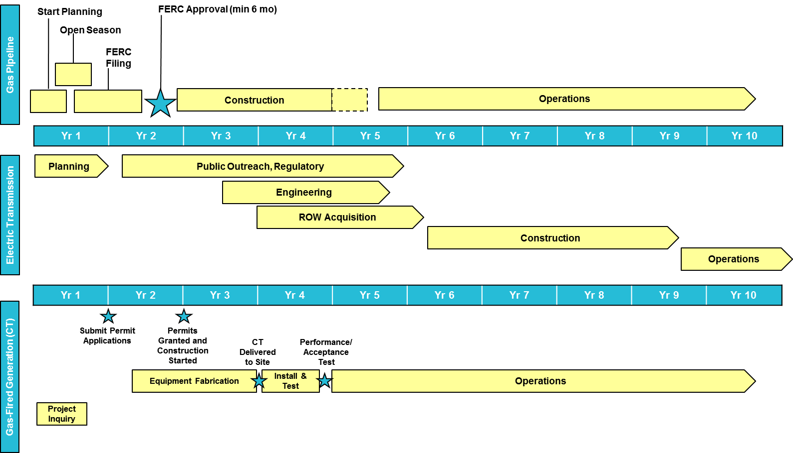
(Sources: Midwest ISO; ScottMadden)

There is currently no mechanism or incentive for the optimization of resources across these industries. There could well be sub-optimal solutions (from a reliability perspective) implemented due to the lack of coordinated planning across this infrastructure. Even for the few integrated utilities who own all three—gas pipelines, electric transmission, and gas-fired generation—the regulatory and market structures do not encourage optimizing the overall gas-power system. Instead, they encourage optimizing only parts of the value chain.

It can be argued that in many cases building a transmission line is the less expensive way to guarantee access to supply for a given region. However, due to the length of time and difficulty of building a transmission line in comparison to a gas plant and pipeline infrastructure, the industries may well end up building whatever is easier without full consideration of the attendant risks.

Different Trading Days: Another Barrier
Since gas-fired generation began to serve as the marginal fuel in many regions and as bid-based markets grew, both industries acknowledged the challenges of different daily trading cycles. These differences mean the timing of commitments is out of phase. In bid-based markets, generators may have to commit to run before they know if they can get gas transported to their units. Or they can assume commercial risk and commit to the gas before they know if their units will be called upon to run. In many cases, real-time generator commitments are made after nominations are required to move gas on a pipeline. This can leave a generator to rely upon the capacity release market, which is not firm and may not provide sufficient assurance of fuel supply for those generators.
There has been much discussion about aligning the gas and electric trading day. One clear challenge is the electric day, which is not uniform across the country. Differences in the electric day stem in large part from differing market structures—day-ahead and real-time bidding in bid-based markets vs. unit commitment and dispatch and bilateral arrangements in bilateral markets such as the Southeast and the Northwest. Historical practice plays a role as well. These kinds of differences are illustrated in Figure 2.

Figure 2: Gas and Power Days in New England

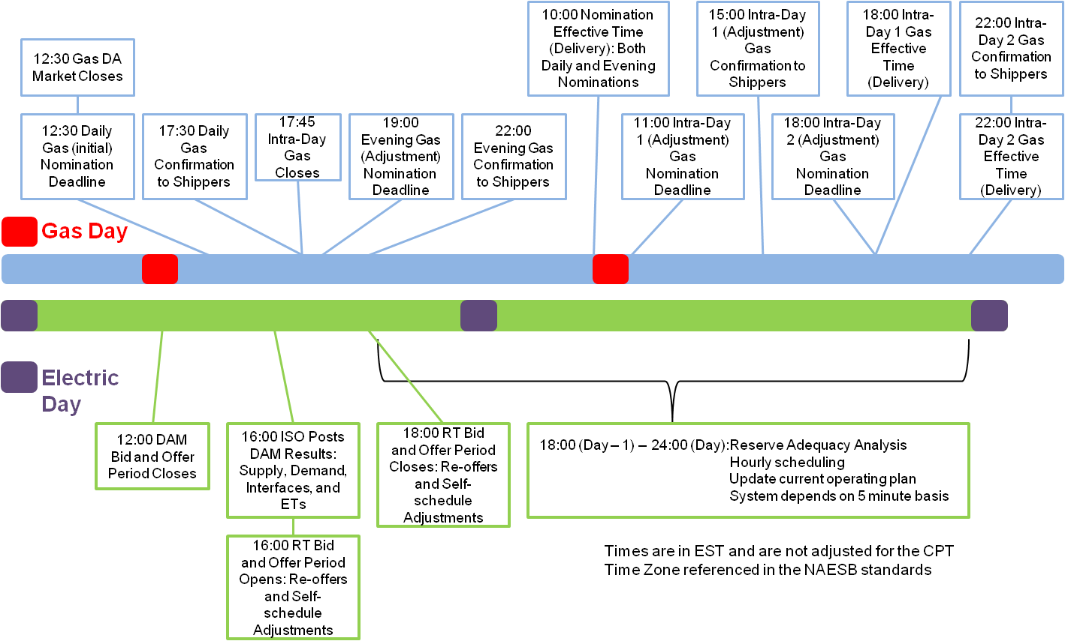
(Source: NERC)

Is Gas-Power Interdependence a National Issue or a Regional Issue? Does It Matter?
It is both. And it matters.

The entire country is becoming more dependent on gas-fired generation, but the level of dependency and experience in dealing with interdependence is very different across regions in the United States. As noted above, electric market structures, rules, and practices vary by region as well. Interdependency issues become more acute with higher reliance on gas. And changes needed to address interdependence risks, will vary with regional market structure. Therefore, many have argued that solutions should be regional as well.
The map in Figure 3 illustrate factors that complicate or facilitate a solution in each region. New England, Texas, and portions of Western Electricity Coordinating Council are the most challenged by electric-gas interdependence; however, in these regions, this has led to significant dialogue and important regional initiatives to attempt to address the issues. Pipeline companies, regional grid organizations, independent system operators, and others have taken leadership roles in attempting to improve communication and coordination in these regions.

Figure 3: Regional Differences Mean Different Concerns
New England
- End-of-the-(gas) line; history of gas issues
- High winter gas demand; large gas demand centers
- Nearby sources declining
- Constrained interfaces–gas and power
- Bid-based market
- LNG import capability
- Problem identified and being worked
Midwest
- Massive anticipated gas-fired replacements
- High winter gas demand; large gas demand centers
- Bid-based market
- Shale supply in adjacent regions
- Problem identified and being worked
Southeast
- Coal retirements; gas-fired replacements
- Modest winter gas demand
- Bilateral market; traditional cost-based regulation of generation
- Shale supply in adjacent regions
Texas
- Coal retirements; gas-fired replacements
- Already highly dependent on gas-fired generation
- Modest winter gas demand
- Bid-based market
- Ample conventional and unconventional supply
- Separate interconnection
Northwest/Mountain West
- Large intermittent resource build-out
- Significant hydro resources, but need to distinguish capacity and energy needs
- Significant coal-fired capacity; massive retirements not expected immediately
- Available Rockies, Canadian supply
- Largely traditional (non-bid based) market
- Recent pipeline expansions
- Working group established for Northwest
California
- Large intermittent resource build-out
- Heavy reliance upon gas-fired generation
- “Peaky,” low cap-factor gas needs for renewable capacity backstop
- Available gas supply in West
- Generally more temperate
- Large gas demand centers (SF, LA)
- Bid-based market
- Generator, gas transmission communication taking place
Desert Southwest
- Heavy reliance upon gas-fired generation with more on horizon
- Complicates solution
- Facilitates solution

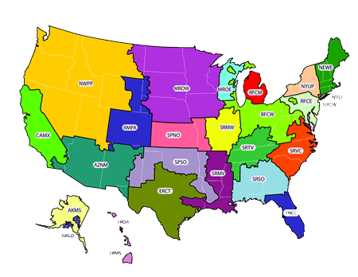

(Source: ScottMadden)
Differing regional endowments of resources and infrastructure and differing local acceptance of infrastructure expansion will govern how acute the gas-power interdependence issue becomes for a particular energy market. Pipeline and storage build-out will govern the degree to which there is a spillover effect of abundant supply from one region to another. High voltage transmission build-out will determine which regional risks can be mitigated through a broader portfolio of contingency options.

To the extent that a region has geography which accommodates easily accessible storage, this can provide important flexibility for electric generation, especially given its high needs for pressure and volume (please see discussion above). Fuel switching capabilities can also provide mitigation of the risks associated with dependence on gas. However, environmental regulations will dictate when these plants can run and for how long. Many fuel-agile plants are also very expensive to run. In Phoenix, for example, due to their non-attainment status under the Clean Air Act, generators can run oil-fired units only in dire emergencies.

Possible Solutions – Acting Near-Term to Address a Long-Term Concern
There are a number of approaches that the industry is considering to mitigate the issues created by electric/gas interdependence. These include building and expanding storage (where geographically possible) and pipeline capacity, expanding the use of dual-fuel generation, employing different operational and contracting approaches, and developing pipeline products tailored to gas-fired generators (a selected list of approaches and considerations is shown in Table 2).

The Federal Energy Regulatory Commission (FERC) Can Help…
One of the ongoing challenges to building pipeline capacity is the requirement that the capacity be fully subscribed: for the pipeline to be built, there must be a firm commitment. A beneficial solution would allow the regions to develop mechanisms whereby additional pipeline capacity, which need is acknowledged, is built and paid for by voluntary participants. In organized markets, a complementary mechanism may also be needed whereby owners of gas-fired generation could recover some of these costs through the market.

In addition to the gas transportation capacity recovery conundrum, FERC can help bridge the divide between commitment periods between the two markets. For example, in PJM, a bid-based market, capacity commitments under its reliability pricing model are made triennially, and retail provider of last resort bidding is conducted in three-year staggered tranches. Meanwhile, anchor tenant contracts for firm gas transportation are often made for 10- to 15-year durations. Of course, regions with bilateral wholesale markets and with cost-based retail service have different considerations and longer time frames. FERC could play a role in helping to bridge these duration mismatches.

The alignment of the electric and gas trading days also needs to be addressed, and this will likely only come through FERC guidance. Commissioner Moeller, who has taken a leadership role in assessing electric/gas convergence, recently stated that he believes a FERC rulemaking or tariff change may be necessary, primarily to address this issue. Significant work was done on this challenge several years ago and recommendations were made to NERC and others; however, we are dealing with the same challenges again today (see earlier sidebar discussion). Commissioner Moeller has observed that during the technical conferences during summer 2012, there always came a moment when the participants realized the gravity of these issues.

To the extent that existing standards of conduct prevent or inhibit communications across these industries, FERC should also take the lead in modifying these rules.
In November 2012, FERC provided guidance on allowable communications between the industries and announced that two additional technical conferences on gas-electric issues will be held. In addition, FERC will require power market operators to report quarterly on their progress in addressing issues related to interdependence as well as on any fuel related generator outages.

…But the Regions Should Lead
At present, the lack of alignment in planning horizons between the gas and electric industries has the potential to create sub-optimal results for the location and use of these resources. Integrated utilities, RTOs, and ISOs have the unique perspective to be able to consider the infrastructure of both industries and assist in analyzing this issue.

Transmission planning is required to consider myriad new requirements on the grid (energy efficiency, demand response, aggregated resources, etc.). In certain contexts, planning groups might expand some of these analyses to include the optimal location of generation to support the reliability of the grid. These entities will then need to consider—within constraints of regulation and grid operator independence—how to identify and encourage siting of resources in optimal locations. This is no small order, but it is something the regional transmission organizations should consider. Integrated utilities owning both types of infrastructure are in the unique position of being able to assess options across their systems to ensure reliability for both.

Further, the transmission planning process should begin to factor in contingencies related to reliance on gas infrastructure. At present, the process does not consider loss of a pipeline or the impacts of interruptible contracts on a generator’s ability to respond to electrical emergencies. For planning purposes, if a generator is in the model, it is assumed to be available. In the new world, this assumption may need to be refined to account for new gas-related contingencies.

The regions must also take the lead in facilitating communication and coordination among the parties. In many senses, gas-electric interdependence presents a challenge of misaligned incentives and planning horizons. Both sides are trying to provide reliable service at a reasonable cost while providing a reasonable return to shareholders. At times, these goals are in conflict. For instance, a gas-fired generator may choose to contract for interruptible capacity, because it does not need firm capacity, or the pipeline company must restrict service to a gas-fired plant with an interruptible contract, because it has no capacity available. These types of misalignments need to be resolved between the parties at the regional level. The parties may well be able to provide superior solutions if given the incentive and flexibility to work together.

Conclusion
The evolving interdependence between the gas and electric industries is presenting new and potentially critical reliability challenges. This has become acute in the regions most dependent upon gas-fired generation. The challenges are as follows:

- Emerging electric-gas “co-dependence”
- Increased volumetric requirements
- Reliance on interruptible contracting
- Operational mismatches
- System design vs. developing usage patterns
Fortunately, in those regions of the country most critically impacted, ISOs, RTOs, and industry groups have begun to study and address the issues described in this paper, as summarized in Table 2 below. ScottMadden strongly believes these industry-led initiatives should continue, as regional approaches appear much more likely to succeed in addressing reliability concerns.

However, we believe the magnitude of the risks and opportunities is not yet matched by the responses of many companies and public policy makers. There are significant opportunities for many players to increase reliability for all and to make money from the sea changes occurring in both markets.

Table 2: Various Approaches to Bridging Gas-Power “Seams” Issues

Area | Approach | Description | Issues and Considerations
Infrastructure Enhancement | Enhanced gas pipeline capacity | Development, expansion, or extension of pipelines into gas-constrained power generation demand centers | - Gas pipeline industry already considering expansion of capacity  - Increasing number of projects to transport gas  - Increasingly a grid, not a one-way flow from the Gulf and Canada  - Industry does not, however, build to include a pipeline “reserve margin”  - Pipelines require long-term capacity subscriptions and firm commitments, precisely what power generators are not offering
Infrastructure Enhancement | Enhanced gas storage | Development of storage near power generation demand centers | - Geological potential varies by region and may not provide desired rapid withdrawal  - Above-ground storage is limited in scale and would require public acceptance (NB: similar issues regarding siting LNG terminals)  - Market pricing of storage may make it more attractive with peak pricing  - Like pipelines, currently requires capacity subscriptions and “anchor tenants”
Infrastructure Enhancement | Expanded power transmission | Increasing electric transmission expansion in at-risk gas-dependent but pipeline constrained regions | - Expanding electric transmission is a lengthy process, more so than gas  - Stakeholders and constituents for electric transmission differ from those of gas transmission  - Cost allocation and socialization issues are similar for electric transmission as for gas  - Power transmission also requires “anchor tenants”
Operational Improvements | Improved communication | Increased communication between gas pipeline and power grid operators on power grid and gas transportation situation and contingencies | - Concerns about proprietary information being improperly shared  - Currently regulatory “code-of-conduct” limitations on information sharing may need to be relaxed  - Some regions establishing coordination mechanisms, especially where weather events may warrant
Operational Improvements | Additional intraday nomination opportunities | Increasing the frequency of opportunities within the gas day to nominate additional volumes | - Some regions are contemplating adding additional intraday gas nomination  - Capacity release programs are already in place for market participants to procure, if available, gas transportation  - Intraday nominations help adjust volumes for those with firm transportation, but may provide little aid to firms with interruptible capacity on peak days
Contracting | Cost recovery for firm gas contracts | Increased firm contracting and mechanism for cost recovery | - As more gas-fired generation serves base load duty, willingness of those power generators to enter into firm transportation agreements may increase  - For load following and peaking capacity, the issue is how to socialize costs without putting gas-fired generators “out of the market”  - Could ISOs or RTOs play a role in gas transportation as quasi-capacity product/service, either directly or through a market-based structure  - One key issue: mismatch of gas transportation contracts (5 to 10 years) versus, in some bid-based markets and restructured retail markets, triennial provider of last resort and capacity bidding  - ISOs and RTOs are reluctant to craft fuel-specific rules or structures, as the perceived mandate is fuel neutrality

ScottMadden believes there are holistic policy-level considerations which must accompany these technical solutions to ensure that the two industries build a framework within which to cooperate for the foreseeable future. Some feel this holistic approach, by definition, requires federal (read FERC) intervention. While FERC should continue to provide leadership in this area and undertake select rulemakings to address those issues to which a common standard would be beneficial, by and large, ScottMadden’s view is that regional approaches are much more likely to succeed in a timely manner. We propose that, due to the regional nature of the issues, the solutions should also be regional.

Many factors are driving the dash to gas (e.g., low gas prices, environmental regulation, etc.). This industry shift is not without consequences and, as a result, the gas and electric industries must continue to evaluate the nature and gravity of this convergence and take steps to ensure that reliability across all customers is preserved, business models are adjusted, and public policy is far-sighted and constructive.

MORE INFORMATION
ScottMadden believes that electric/gas convergence poses significant risks, and opportunities, to individual businesses in both the gas and electric industries. Some companies will make money due to this interdependence. And some will find themselves in the newspapers, front page, top of fold.
We recommend that our clients take a longer view of both markets and specifically avoid the herd instinct around gas prices forecasts. Companies impacted by electric/gas convergence should consider cross-gas-electric scenarios during strategic planning and scenario analysis. Identifying and analyzing alternatives that include additional infrastructure build-out and contingency analysis will be important to creating options to address the risks identified above.

Some companies have taken leadership roles in creating dialogue across the two industries, and we believe this is key to reaching resolution. We recommend that our clients participate in and lead the regional discussions taking place. Those leading the dialogue are more likely to agree with the solutions implemented.

For more information or to provide comments on this article, please e-mail Cristin Lyons or Greg Litra.

About ScottMadden, Inc.
Since 1983, we have been energy consultants. We have served more than 300 clients, including 20 of the top 20 energy utilities. We have performed more than 2,400 projects across every energy utility business unit and every function. We have helped our clients develop strategies, improve operations, reorganize companies, and implement initiatives. Our broad and deep energy utility expertise is not theoretical—it is experience based.

Contact Us
Cristin Lyons Greg Litra
Partner, T&D and Smart Grid Leader Partner and Clean Tech & Sustainability Research Lead
2626 Glenwood Avenue 2626 Glenwood Avenue
Suite 480 Suite 480
Raleigh, NC 27608 Raleigh, NC 27608
Phone: 919-781-4191 Phone: 919-781-4191
cmlyons@scottmadden.com glitra@scottmadden.com
www.scottmadden.com www.scottmadden.com

North American Electric Reliability Corporation. 2011 Special Reliability Assessment: A Primer of the Natural Gas and Electric Power Interdependency in the United States (December 2011)
Midwest Independent Transmission System Operator. Embedded Natural Gas-Fired Electric Power Generation Infrastructure Analysis: An Analysis of Daily Pipeline Capacity Availability (July 2012)
NERC, 2011 Special Reliability Assessment, supra note 1, pp. 85-90
SNL Financial. Boston Gas Company in Natural Gas Utility Highlights (2012)
NERC, 2011 Special Reliability Assessment, supra note 1, pp. 88-92
K. Bleskan. “Western Gas, Electric Industries Tell FERC They Need No Help Collaborating.” (SNL Financial, August 2012)

