POWER DECARBONIZATION: PAST AND FUTURE
ScottMadden’s Energy Practice
October 2021
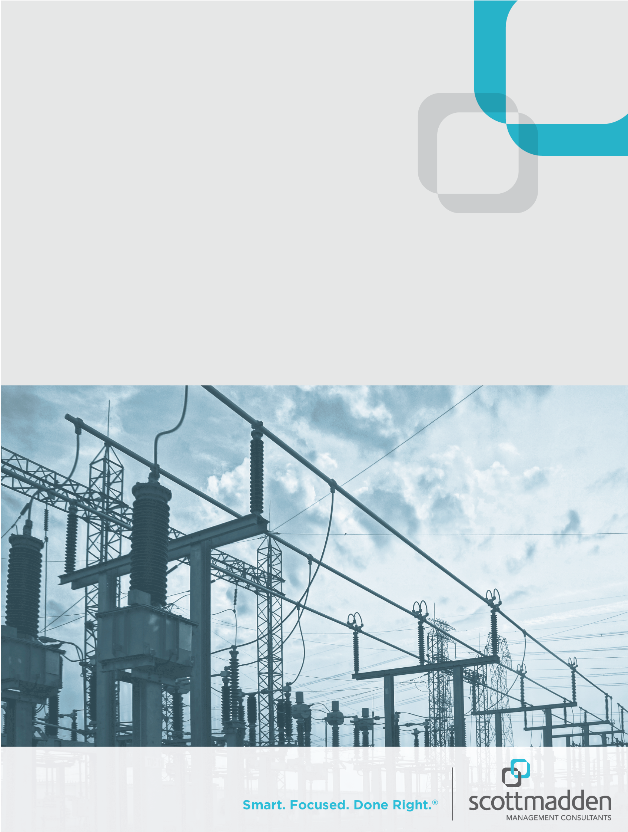

Overview
Decarbonization has become an increasingly important issue in the United States as more states, cities, and utilities commit to net-zero carbon-emissions goals. This report analyzes historical carbon reductions in the electric sector to see how this space has reduced carbon emissions to date. It also examines recent integrated resource plans (IRPs) from electric utilities that have committed to 100% net-zero carbon targets to gauge how decarbonization efforts may shift in the future.

Our analysis finds that since 2005 fossil fuel switching (e.g., switching from coal to natural gas generation) has provided more emissions reductions than the addition of renewable generation. Fossil fuel switching has also produced significant carbon reductions (in absolute terms) in locations that lack robust state policies supporting renewable energy.

The review of IRPs finds utilities pursuing 100% decarbonization anticipate rapidly expanding utility-scale renewables and energy storage, while maintaining natural gas generation as a critical resource for reliability purposes.

This shift in reductions, which was historically largely due to fossil fuel switching but is anticipated to be from carbon-free generation and energy storage in the future, highlights the changing nature of the decarbonization landscape in the U.S. power sector. More importantly, it showcases the complexity faced by utilities as they build decarbonization plans while recognizing there is no single cost-effective technology that allows a utility to decarbonize 100%. A variety of mature technologies, like non-coal generation (i.e., natural gas, solar, wind, nuclear, etc.) and energy efficiency programs, may need to be partnered with nascent technologies, like energy storage, carbon sequestration, and small modular nuclear generation, in order to achieve 100% net-zero emissions goals.

The History of Decarbonizing Electricity
To understand electricity-related carbon-emissions reductions in the United States, ScottMadden first reviewed emissions by sector. Historically, the electric sector was the largest source of carbon emissions. However, electric sector emissions peaked in 2007 and have since been trending downward. In fact, electric sector carbon emissions are now on par with emissions last seen in 1979 (see Figure 1). The transportation sector is also noteworthy. After remaining relatively stable over the last decade, transportation became the largest source of energy-related carbon emissions in 2016.

Figure 1: U.S. Carbon Emissions from Energy Consumption by Sector (in MMT CO₂), 1973–2020

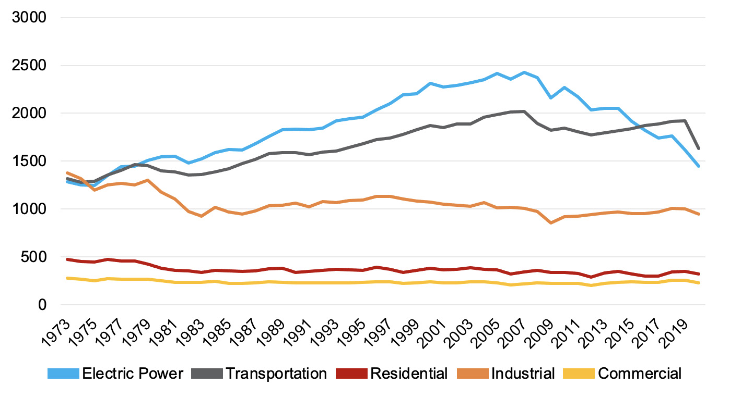

Next, we wanted to analyze the key drivers of decarbonization occurring in the electric power sector from 2005 to 2020. We chose 2005 as the starting year of the analysis because President Obama, under the Paris Climate Agreement, committed the United States to reduce overall greenhouse gas emissions by 26% to 28% below 2005 levels by 2025.

ScottMadden leveraged a methodology developed by the Energy Information Administration (EIA) for this analysis. Specifically, the methodology reviewed emissions reductions associated with 1) switching carbon-intensive fossil fuel generation, like coal and petroleum, to natural gas and 2) increasing generation from carbon-free sources (e.g., solar, wind, and nuclear). The analysis compares the carbon intensity of the baseline year against all future years, and the impact of variables, like weather and electricity demand, is incorporated into each year’s carbon intensity.

The output of this analysis shows the annual carbon-emissions reductions in the two reduction categories (see Figure 2). Carbon reductions from fossil fuel switching outpaced carbon reductions from carbon-free generation increases in each year of the analysis. Over the full study period, fossil fuel switching reduced carbon emissions by 3,915 million metric tons (MMT), which accounted for about 61% of all carbon reductions. Meanwhile, increases in carbon-free generation drove 2,551 MMT or about 39% of CO₂ reductions.

Figure 2: Annual U.S. Electric Power Sector Carbon Reductions by Type (in MMT CO₂), 2005 – 2020

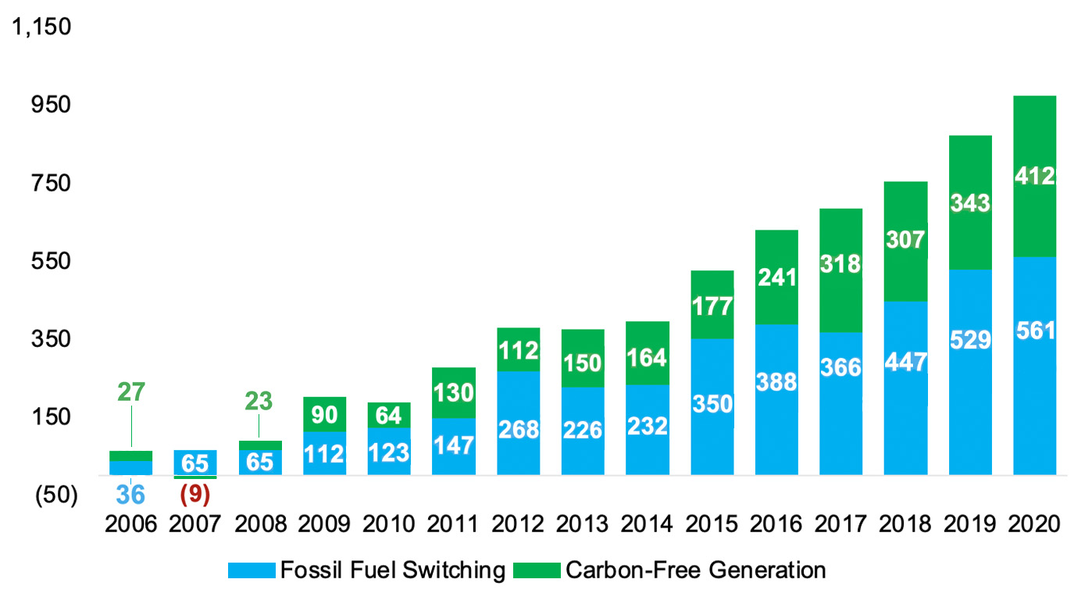

We also examined carbon-free generation reductions by technology type. Increases in wind generation were responsible for the majority of these carbon-emissions reductions (see Figure 3). Solar generation was the second-largest source of reductions. While nuclear and hydro generation provide the majority of carbon-free electricity in the United States, they are not prominent in the results because the output from these resources did not change significantly during the study period.

Figure 3: Carbon-Free Generation Carbon Reduction by Technology, 2005–2020

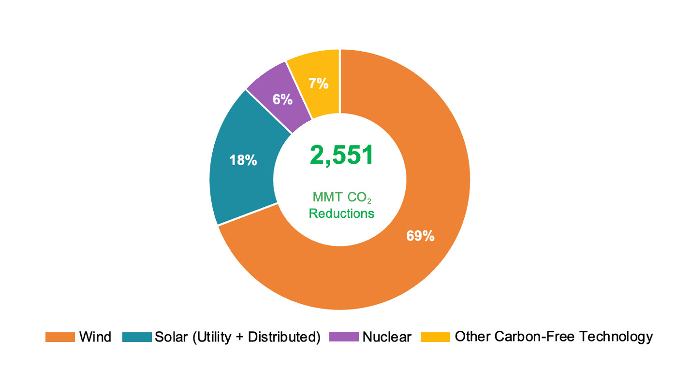

We also examined historical state-level carbon-emissions reductions (see Figures 4 and 5). Several noteworthy findings emerged from this analysis. First, Texas led the country in carbon-emissions reductions, largely due to the build-out of its wind fleet. Second, southeast states showed significant reductions from fossil fuel switching. Even more notable is that the reductions were achieved in a region in the country that largely lacks renewable portfolio standard (RPS) requirements.

Overall, the states with the most reductions tended to have larger generation footprints and high-carbon emissions in the baseline year. This proved particularly important for a state like California that has a history of climate-focused legislation. By 2005, the state had removed most fossil fuel generation. Because of this, the state did not have a high-carbon intensity in the baseline year and, as a result, had fewer carbon-emissions reductions than many other smaller states. See case studies below for further discussion of California.

Figure 4: Fossil Fuel Switching CO₂ Emissions Reductions by State (in MMT CO₂), 2005–2020,

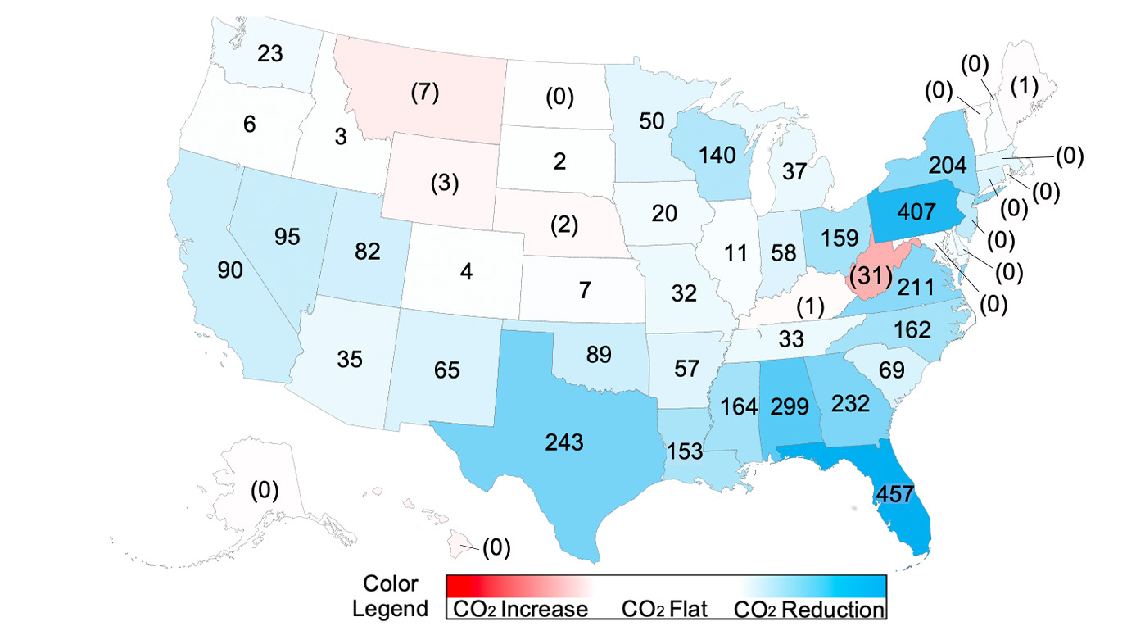
Figure 5: Carbon-Free Generation Reductions by State (in MMT CO₂), 2005–2020

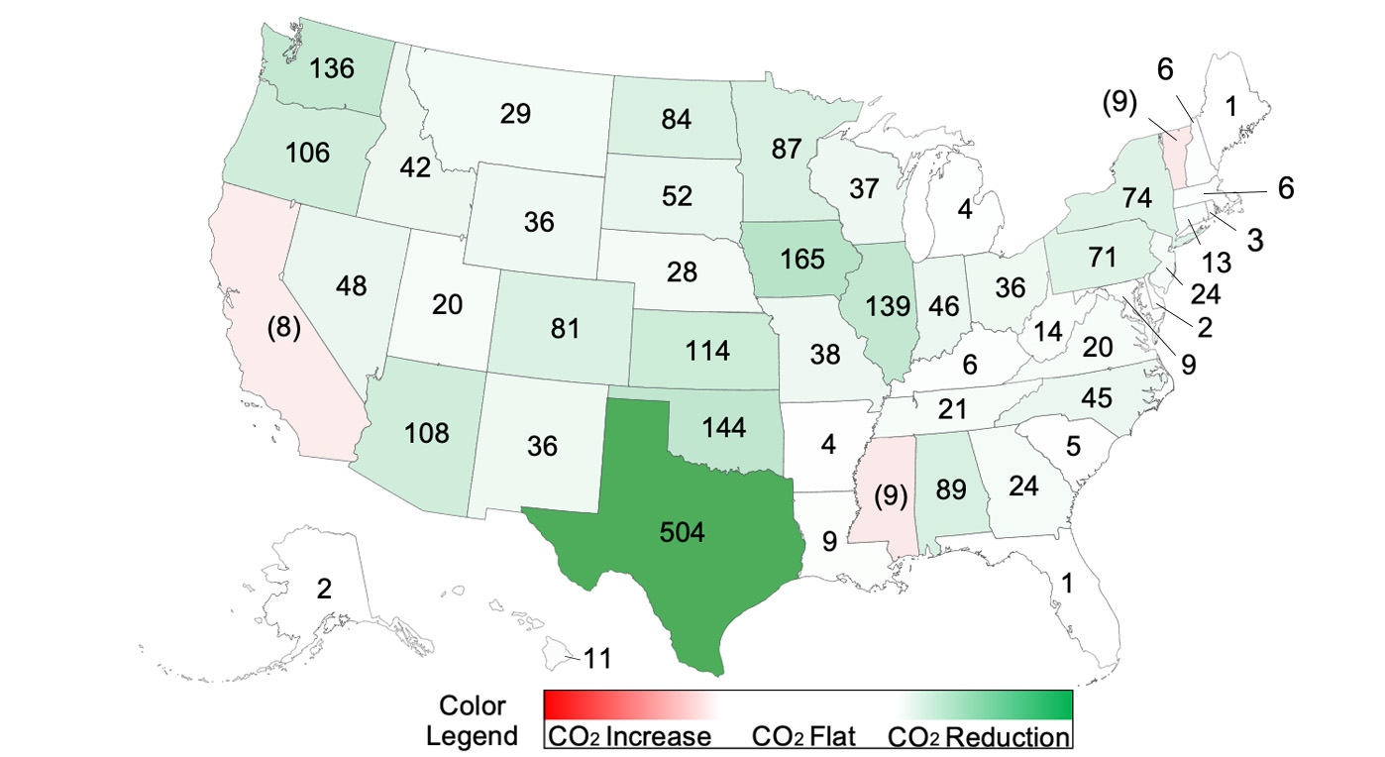

Case Studies: Three Paths to Decarbonization
A closer examination of individual states reveals the different paths that states followed to reduce carbon emissions. In the table below, we highlight the source of carbon reductions and key observations from California, Alabama, and Iowa. The divergent paths followed by these states illustrate that multiple levers exist to reduce carbon emissions.

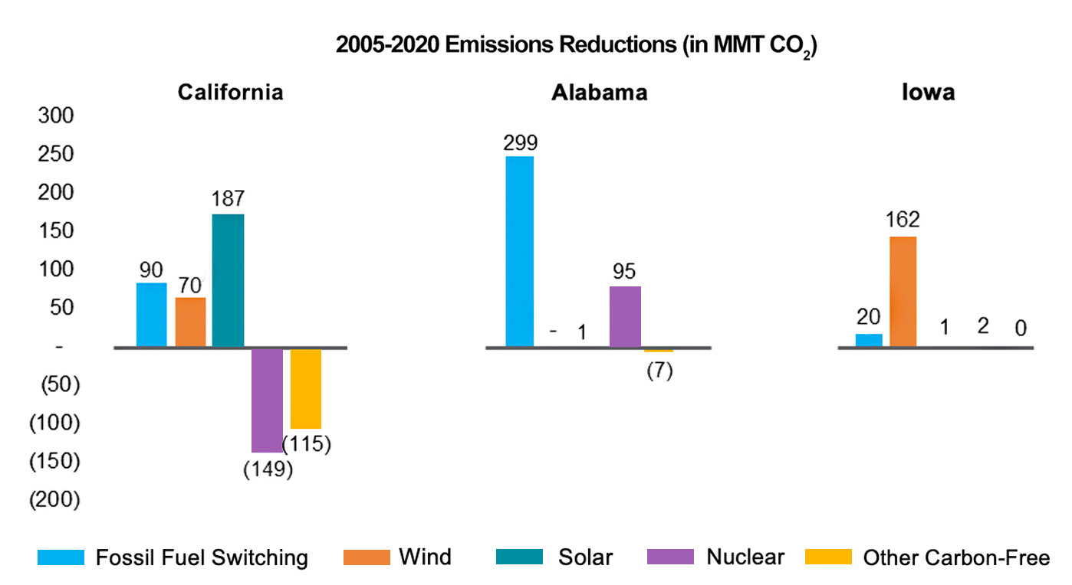
Key Observations
California | Alabama | Iowa
California eliminated most of its coal generation by 2005. As a result, the state saw limited emissions reductions from fossil fuel switching.  Meanwhile, emissions reductions from increasing solar and wind were offset by decreases in nuclear and hydropower generation over the study period.  Lessons from California show that emissions reductions can be limited if carbon-free resources are retired, most notably nuclear generation. | Since 2005, Alabama shifted much of its coal generation to natural gas, resulting in significant reductions in carbon emissions.  The state also increased its nuclear generation output, driving additional carbon reductions.  Alabama illustrates how fossil fuel switching has been a critical driver for carbon-emissions reductions since 2005. | Iowa is a leader in wind generation. In 2019, the state’s wind generation, as a percentage of in-state generation, ranked first in the United States.  The wind fleet has driven the majority of the state’s carbon-emissions reductions since 2005.  While renewable resource availability varies by location, Iowa illustrates how renewable resources can be leveraged to drive substantial carbon-emissions reductions.

Largest Opportunities Moving Forward?
Significant progress has been made toward decarbonizing the electric sector, yet many states still rely on carbon-intensive coal generation. A state-level breakdown of these emissions shows the majority of states still use coal in their generation mix, and there are significant emissions from these resources in Texas and the northeastern portion of the Midwest (see Figure 6). This breakdown showcases states that have the greatest opportunity for coal-related carbon reductions through fossil fuel switching or by replacing coal with carbon-free generation, like wind and solar.

Figure 6: Carbon Emissions from Coal Power Generation by State (in MMT CO₂), 2019

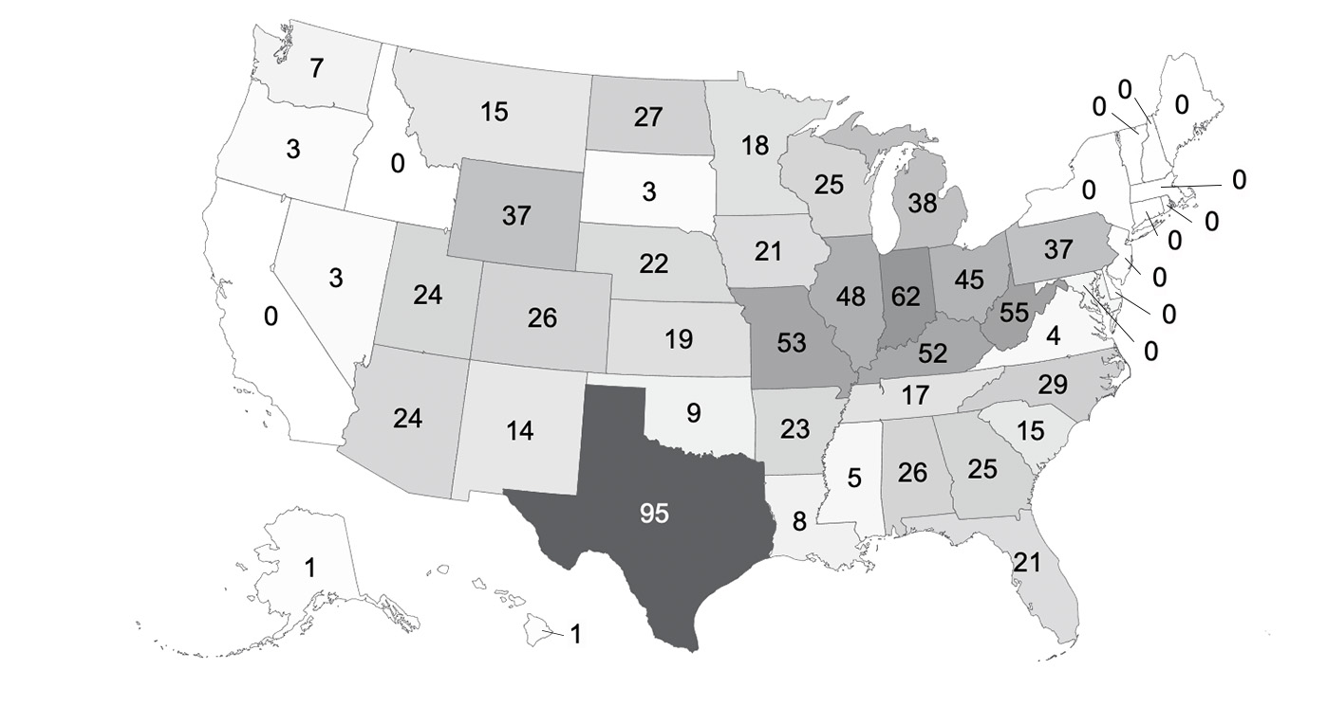

The key question moving forward will be “which path will states and utilities follow for future carbon-emissions reductions?”

As mentioned above, one strategy is clearly to build new natural gas generation to replace coal if there are coal emissions to be replaced, as this has historically driven the majority of carbon reductions. However, natural gas generation still emits carbon, and if additional states or utilities mandate net-zero targets, these new generation sites will need to offset their emissions with carbon capture or carbon-sequestration technology, both of which require technology cost decreases to achieve cost-effectiveness.

Another strategy is to build additional renewable energy. New renewable generation could replace coal generation directly. Also, in states with little to no coal generation, increasing renewable generation will be the primary driver of additional emissions reductions. The most popular renewable technologies, wind and solar, have become cost-effective in many locations, but these resources are variable and must be balanced with natural gas or energy storage to provide reliability.

Ultimately, a combination of these two strategies, which balances the risks and advantages of each, is the likely path forward for utilities. To understand how utilities are approaching these strategies, we examined the IRPs of several major utilities. The results of this analysis are discussed in the next section.

The Future of Decarbonizing Electricity
ScottMadden reviewed a sample set of utility announcements and IRPs to understand these utilities’ decarbonization strategies. Since 2018, a growing number of electric utilities have announced ambitious plans to achieve 100% clean energy by 2050 or sooner. Many initial announcements provided limited details on resource selection, costs, or impacts on reliability. More recently, several investor-owned utilities, which have committed to 100% clean energy, filed IRPs detailing how they plan to pursue decarbonization pathways over the next 15 years.

ScottMadden reviewed IRPs from five of these utilities to identify common themes and strategies that may provide a roadmap or some pointers to other electric utilities considering carbon-reduction goals or strategies. More specifically, ScottMadden reviewed IRPs from the following vertically integrated, investor-owned utilities:

- Xcel Energy Inc.’s Northern States Power Company, covering its upper Midwest service territory in Michigan, Minnesota, North Dakota, South Dakota, and Wisconsin
- Arizona Public Service Company (APS), covering its Arizona service territory
- Duke Energy Carolinas and Duke Energy Progress (collectively Duke Energy), covering their North Carolina and South Carolina service territories
- Dominion Energy’s Virginia Electric and Power Company, covering its Virginia service territory

Each IRP was published after the parent company announced a commitment to achieving 100% clean energy. In Virginia, Dominion Energy is also subject to a state law requiring 100% clean energy.

A clear focus across all IRPs is the intent to significantly expand renewable energy and battery storage capacity. The majority of capacity additions are planned in later years, thereby allowing technology costs to continue to decline. The expansion of renewables and storage was a key trend across the five utilities and, when provided, across scenarios within individual IRPs.

The renewable energy and storage build-outs will cost electric customers more than new natural gas-fired generation. However, expected cost increases are generally below the utilities’ projected rate of inflation over the planning periods.

The following table provides a summary of the renewable and storage additions, as well as projected cost impacts found in our sampling of IRPs.

Key Findings from Recent 100% Clean Energy IRPs
Utility | Carbon Target | Results for Least-Cost Decarbonization Scenario
Utility | Carbon Target | Renewable Additions | Storage Additions | Cost Impacts
Xcel Energy | 100% carbon-free electricity by 2050 | 4,000 MWs of utility-scale solar; 1,400 MWs of onshore wind | 1,700 MWs of “firm, dispatchable load supporting resources” | Customer costs increase 1.1% per year compared to 2.4% for inflation
APS | 100% carbon-free electricity by 2050 | 6,450 MWs of utility-scale solar and onshore wind | 4,850 MWs of storage | G&T system costs increase 1.3% per year compared to 2.5% for inflation
Duke Energy | Net zero by 2050 | 8,375 MWs of utility-scale solar; 750 MWs of onshore wind | 2,200 MWs of storage | Residential bills increase 1.5% per year; no inflation assumption provided
Dominion Energy | Net zero by 2050 | 16,000 MWs (1,000 MWs distributed); 5,000 MWs of offshore wind | 2,714 MWs of storage | Residential bills increase 2.9% per year; no inflation assumption provided

Even with the growth of renewables and storage, the IRPs indicate natural gas will remain an important component of the electric grid. With the exception of scenarios that intentionally eliminate natural gas generation, all IRP scenarios use natural gas generation to ensure power grid reliability. Some utilities expect to keep natural gas capacity relatively constant (e.g., Xcel Energy), while others expect to add incremental natural gas capacity (e.g., Duke Energy) during the IRP-planning periods.

The IRPs also show a clear trade-off between affordability and more aggressive carbon reductions. Scenarios with deep carbon reductions often require accelerating the addition of renewable energy and battery storage capacities. Some also considered technologies that are not yet cost-effective, like long-duration storage, small modular nuclear, or carbon capture technology.

We expect these IRPs will continue to evolve over time. The near-term focus is clear: build renewables and battery storage. Over the long-term, the push toward deeper decarbonization could take multiple paths. Important signposts to monitor will be cost declines in existing carbon-free technologies and the emergence of new, cost-effective net-zero technologies.

Implications
The growing shift to decarbonize the electric power sector will require utilities to evolve their generation assets and business models. Success will require developing an understanding of current carbon-emissions profiles, while preparing for higher penetrations of renewables and other net-zero carbon technologies.

Utilities will need to consider building new natural gas and/or renewable generation to drive carbon reductions. Each option carries its own set of risks, as natural gas generation may be subject to future portfolio reviews if net-zero policies are adopted and the dominant forms of renewable generation are variable and require pairings with other technologies to ensure grid reliability. Utilities need to consider these risks when forecasting capacity installations and building IRPs.

The transition to net-zero carbon-generation resources will be a major theme over the next 25 years. Electric utilities can take concrete steps today to ensure they are prepared with a thoughtful approach. Even more importantly, early actions will allow electric utilities to ensure that decarbonization is done in a cost-effective manner while ensuring reliability.

Contact Us
Energy supply in the United States is on the cusp of significant changes. Renewables offer a solution by increasing fuel and geographic diversity while lowering emissions profiles. The scale and scope of renewables will continue to expand, and this shift will require grid operators to balance intermittent resources, adapt to bi-directional power flows, and manage the integration of distribution generation assets.

Developing a comprehensive understanding and approach to the growth of clean and renewable technologies is complex and time consuming, requiring a unique combination of skills. These skills are why our clients turn to us.

ScottMadden can provide support in emissions modeling, resource analysis, and pilot project guidance for utilities preparing for this future. Our clients have included utilities, industrial companies, the federal government, and more, and we can support activities ranging from strategy development to program design to asset management best practices and optimization. Please contact us to learn how we may help.

About ScottMadden, Inc.
ScottMadden is the management consulting firm that does what it takes to get it done right. We consult in two main areas—Energy and Corporate & Shared Services. We deliver a broad array of consulting services ranging from strategic planning through implementation across many industries, business units, and functions. To learn more, visit www.scottmadden.com | Twitter | Facebook | LinkedIn.

About ScottMadden’s Energy Practice
We know energy from the ground up. Since 1983, we have served as energy consultants for hundreds of utilities, large and small, including all of the top 20. We focus on Transmission & Distribution, the Grid Edge, Generation, Energy Markets, Rates & Regulation, Enterprise Sustainability, and Corporate Services. Our broad, deep utility expertise is not theoretical—it is experience based. We have helped our clients develop and implement strategies, improve critical operations, reorganize departments and entire companies, and implement myriad initiatives.

About the Authors
Paul Quinlan is ScottMadden’s clean tech manager. Mike Kerrigan is a senior associate at the firm.

For further discussion on energy efficiency programs and deployment, see ScottMadden’s “Six Keys for Utilities to Successfully Scale Energy Efficiency Programs” at https://www.scottmadden.com/insight/six-keys-for-utilities-to-successfully-scale-energy-efficiency-programs/
EIA, Monthly Energy Review
The Paris Climate Agreement is an international environmental accord designed to substantially reduce global greenhouse gas emissions in an effort to limit the global temperature increase to two degrees Celsius above pre-industrial levels. In June 2017, President Trump announced the United States would exit the Paris Climate Agreement. The United States officially withdrew in November 2020, but President Biden signed an executive order on his first day in office directing the United States to rejoin the Agreement.
EIA, U.S. Energy Related Carbon Dioxide Emissions, September 2020
More specifically, the methodology calculated carbon-emissions intensity of the power sector in a given baseline year and then forecasted emissions in future years assuming the baseline carbon intensity was held constant. The reductions were calculated as the difference between the forecasted and actual emissions. It is worth noting that all emissions and generation measurements were based on intra-state generation and did not take into account energy imports.
The negative values represent a reduction in carbon-free generation, like nuclear and hydropower, that was backfilled with carbon-emitting fossil generation.
EIA, U.S. Electric Sector Emissions and Generation Data
The only states in the Southeast with RPS requirements are North Carolina and Virginia. North Carolina enacted a renewable energy and energy efficiency portfolio standard in 2007. Virginia enacted a clean energy standard in 2020.
2020 state-level fossil fuel emissions reductions are subject to change with EIA data updates.
Negative values in this chart present a net increase in emissions from coal generation over the study period.
2020 state-level carbon-free generation emissions reductions are subject to change with EIA data updates.
For further discussion on impacts of early retirement of nuclear assets, see ScottMadden’s “One Step Forward, Two Steps Back… The Worsening Risk of Losing Carbon-Free Generation in the United States” report at https://www.scottmadden.com/insight/one-step-forward-two-steps-backthe-worsening-risk-losing-carbon-free-generation-united-states/

